PROJECT SRS DOCUMENT

DATE – Sunday,February 24,2013

SECRET CYBER INVESTIGATION AGENcY

Version 1.1

Submitted to:

Prof Swathi J.N

-Naga Malleswara Rao(10bce0114)

-Saurav Majumder (10bce0274)

-Saketh P (10bce0495)

Presented on: 11 March 2013

**Table of Contents-**

1. **Revision History………………………………………………………………………………………………………..3**
2. **Basic Regulations………………………………………………………………………………………………………3**
   1. Constraints………………………………………………………………..3
   2. Definitions, Abbreviations and Acronyms………………….3
3. **Aim……………………………………………………………………………………………………………………………4**
4. **Project Overview……………………………………………………………………………………………………….4**
   1. Problem Description…………………………………………………….4
   2. User Stories………………………………………………………………….5
   3. Scope……………………………………………………………………………6
   4. Process Model Identification and Scheduling………………..6
   5. Key contacts and Stakeholders………………………………………9
5. **Project Schedule…………………………………………………………………………………………………………9**
   1. Major Project Milestones……………………………………………….9
   2. Work Breakdown Structure…………………………………………….10
   3. PERT Chart……………………………………………………………………..11
   4. Gantt Chart………………………………………………………………..11
   5. Timeline Chart……………………………………………………………………12
6. **Project Resource Requirements……………………………………………………………………………....12**
   1. Hardware Resource Requirements………………………………..12
   2. Software Resource Requirements………………………………….12
7. **Risk Management…………………………………………………………………………………………………….13**
   1. Risk Management Strategy………………………………...............13
   2. Initial Risk List…………………………………………………………………13
8. **User Requirements…………………………………………………………………………………………………………14**
   1. Functionalities…………………………………………………………..14
   2. User Characteristics………………………………………………………….15
9. **External Interface………………………………………………………………………………………………………….16**
10. **System Requirements………………………………………………………………………………….16**
    1. Requirement Gathering(traceability matrix)………………………16
    2. Functional Requirements…………………………………………………..17
    3. Non-Functional Requirements…………………………………………..19
    4. Domain Requirements……………………………………………………….21
11. **Object Oriented Analysis and Design-(UML Modeling)-………………………………………………………………22**
    1. USE CASE………………………………………………………………………………..22
    2. DATA DICTIONARY………………………………………………………………………24
    3. SYSTEM DESIGN……………………………………………….24
       1. SEQUENCE…………………………….……………24
       2. COLLABORATION……..………………………..27
12. **Architecture Model Identification & Explanation……………………………………………………………………….29**

12.1 System Structuring………………………………………………………………………29

12.2 Control Models…………………………………………………………………………...30

12.3Modular Decompostion……………………………………………………………….31

**1) Revision History:**

|  |  |  |  |
| --- | --- | --- | --- |
| **Name** | **Date** | **Reason For Changes** | **Version** |
| Agency | 14/2/2013 | User requirement not matching system requirement. | 1.0 |
| Agency | 24/2/2013 | Use case change | 1.1 |

**2) Basic Regulations-**

**2.1 Constraints-**

2.1.1 Priority is given to confirmed cases rather than the suspicious ones and also the magnitude of the roll is measured (TS job) as in bank or credit card theft is given a higher priority than a hack of a twitter account.

2.1.2 The tracking supervisors (TS) must make sure that their respective trackers are tracking/following the correct module and not falling out of their allotted track.

2.1.3 The online server is the Administrator of the project, and it updates the firewall for sites based on their issue of permission and the security that is already available on the site.

2.1.4 The people who are taking care of maintaining the Database in the tracking agency are constantly doing so as to avoid stagnation of data.

2.1.5 Not more than 2 cases are handled by a particular tracker at a point of time.

2.2 Definitions, Abbreviations and Acronyms:

|  |  |
| --- | --- |
| **Abbreviation** | **Definition or designation** |
| SCIA | Secret Cyber investigation Agency |
| TS | Tracking Supervisors |
| ADMIN | Administrator |
| WBS | Work Breakdown Structure |
| TA | Tracking Agency |
| OlS | Online Server |

**3.)AIM :**

The following project aims to develop a scene software for a certain secret cyber agency.In this,we develop a web based application which interactively maps the design and functioning of an agency which monitors the activities in a city to keep the criminal cyber activities like phishing and username/password theft under control with a successful crime solving rate.Secret tracking officers are used to solve complex cases where an interactive system is maintained to ensure secure transfer of information between agency and its agents.This type of software has a wide scope in the future so that the government with the help of ministry and the agency can keep track and live with a crime free environment.

**4.)PROJECT OVERVIEW**  :

**4.1 Problem Description:**

In todays World,we need to ensure that hacking cannot be done on major sites such as the daily central shopping forums,e-commerce and Social Networking sites in general.So we implement a secret cyber investigation agency where we make secret officials called the TRACKERS who work on individual modules and cases that are assigned to them based on the complaints that they get from the users in the market who are attacked or thought they are a live target of any software mishap or cyber defaulting.3 things that hackers mainly concentrate on in this domain are

i)Credit Card Details

ii)Username/Password details

iii)Spam mail and Stalking(giving random mail and getting us to open sites which on opening give them profit and put virus into our system).

So,this is a project based to avoid the whole idea completely and as mentioned above,catch criminals with a very high crime solving rate.

We can use various modules like an online server,tracking supervisor,tracker,Phishers and a us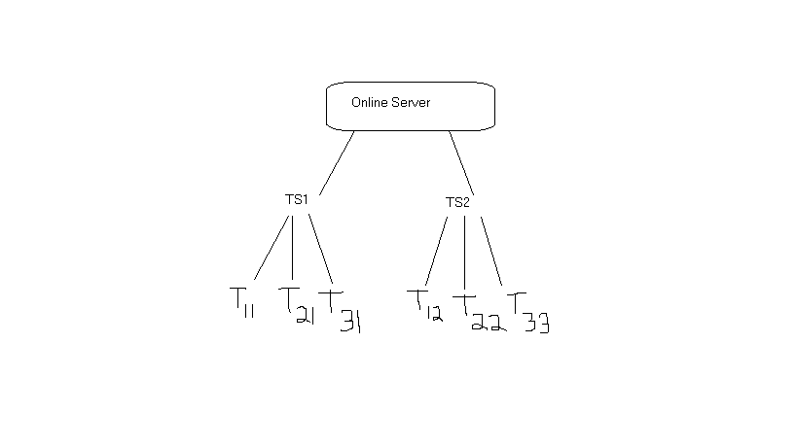

***4.2 User Stories :***

***O*nline server-**

a) Define the various domains in which the tracking team needs to be deployed

b) Depending on severity of the act of phishing, the tracking team must take necessary remedial measures.

c) Forum for users to post their problems

d) Updates the firewall and security boundaries laid down by the different websites

**Tracking supervisor-**

1. Maintains the database of the listed attackers who have been previously caught on sites like rapidshare, facebook, myspace etc.
2. Security requirements – login with access code, proper logs of tracker activity maintained( tracker may turn rogue).

**Tracker-**

1. Uploads the IP, MAC address, owner, billing information, browsing history of hacker
2. Encrypted data needs to be sent to the tracking supervisor (Diffie-Hellman , RSA algorithm can be applied) to prevent 3rd party intervention.
3. Has to submit weekly reports to the tracking supervisor so as to check whether the case is progressing forward so that they can catch the culprit or it has to be followed as a different detail.

**Customer-**

1. Provides suspect names.
2. Filing cases if attacked by a hacker or is a prey of phishing, directly contacts online server.

**4.3 Scope :**

This software has a very wide scope in future as with time technology is on the up rise and an efficient,fast and secure mode of communication needs to be provided so that the government with the help of the ministry and agency of cyber safety can provide a secure browsing system environment. This scene software has been developed ensure a cybercrime free environment where users are protected from hackers and their phishing attacks.

This software can be used in multiple domains even though we have restricted this to only online shopping forums and social networking sites. This software is of immense help to the government if they implement it to restrict hackers from attacking home users and sniffing out personal details.

It has a future in all projects which require secure transfer of information keeping the contents of transfer at bay from the hackers.

**4.4 Process Model Identification & Scheduling:**

Our desired project has the following functional requirements:

1. High reliability
2. Risk analysis and management plan
3. Secure data transfer, encryption module is used extensively
4. Fast upload of data
5. Minimum resource constraint (memory, cost and power)

Keeping in mind the above requirements, we see that the incremental SDLC model is best suited for the following reasons:

**Incremental Delivery Model:**

1. Requirements are well defined and well known beforehand
2. The model provides flexibility and provides the privilege to update the software and database
3. Customer (Online server) has the privilege to respond to each build. Once a code package is complete the customer checks and suggest changes
4. Incremental SDLC provides a proper risk analysis plan which helps to increase level of security or provide prompt event handling in case of system handling
5. Highest priority services are delivered first, the most important system services receive the most testing.
6. Here, there is a very lower risk of overall software failure. Since, each module is developed separately.

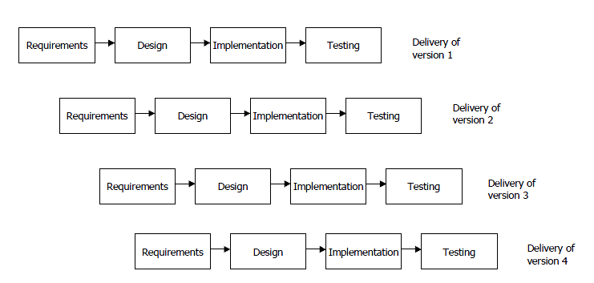 INCREMENTAL MODEL FIGURE

**Justification for Not Choosing Other Models-**

1. Waterfall Model –

* All requirements should be known upfront and cannot be modified later.
* Provides limited flexible as once modules are designed they are implemented without chance for further modification.
* Little opportunity for the customer to preview the system
* Integration is a big problem at the end.

1. Rapid Prototyping –

* Can lead to an unstable and badly maintained prototype.
* Customers are non‐technical and usually don’t know what they want/can have.
* Difficult to know how long project survey will take.

1. V-shaped SDLC –

* Does not contain risk analysis activities.
* Does not easily handle concurrent events.
* Does not easily handle dynamic changes in requirements.
* Does not handle dynamic changes in requirements.

1. Code and fix –
   * No visibility or control
   * No deadlines
   * No resource planning
   * Disastrous for such a large project.
2. Spiral Model –
   * For projects with limited idea about user requirements.
   * High administrative overhead
   * 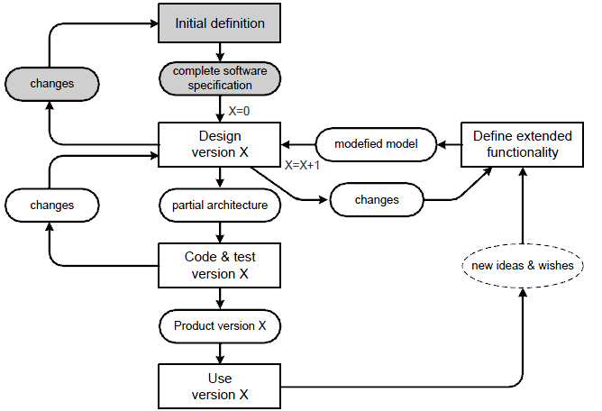Tedious process followed to accommodate small changes.

**FLOW CHART OF INCREMENTAL MODEL**

**4.5)Key contacts and Stakeholder Identification:**

DIRECT CONTACTS:

|  |  |  |
| --- | --- | --- |
| NAME | REGISTRATION NUMBER | PHONE NUMBER |
| Naga Malleswara Rao | 10BCE0114 | 07200301665 |
| Saurav Majumder | 10BCE0274 | 08754259905 |
| Saketh P | 10BCE0495 | 09790010884 |

OTHER INDIRECT CONTACTS (may include ourselves) :

1. Administrator(Online Server).
2. Database Manager.
3. System Engineer.
4. Tracking Supervisors.
5. Trackers.
6. Analyst.
7. Users(complaint lodgers).
8. Advertizing team.

**5 PROJECT SCHEDULE :**

**5.1 Major Project Milestones:**

|  |  |  |  |  |
| --- | --- | --- | --- | --- |
| **Milestone** | **Estimated Start** | **Estimated End** | **Estimated Hours** | **Number of Days** |
| Problem description and stakeholder identification | 8/2/13 | 18/2/13 | 33 | 11 |
| SRS discussion | 19/2/13 | 1/3/13 | 33 | 11 |
| Setting up online server | 2/3/13 | 12/3/13 | 33 | 11 |
| Testing functionality | 13/3/13 | 15/3/13 | 9 | 3 |
| Creating manger’s UI and message passing | 15/3/13 | 19/3/13 | 15 | 5 |
| Testing delivery of messages | 20/3/13 | 22/3/13 | 9 | 3 |
| Creating tracker’s UI and reporting | 22/3/13 | 2/4/13 | 36 | 12 |
| Testing the system | 3/4/13 | 7/4/13 | 15 | 5 |
| Creating online forums | 8/4/13 | 11/4/13 | 12 | 4 |
| Testing and resolving issues | 12/4/13 | 27/4/13 | 48 | 16 |
| Installation and going online with  Maintenance | 27/4/13 | ------ | ------- | -------- |

**5.2 Work Breakdown Structure:**

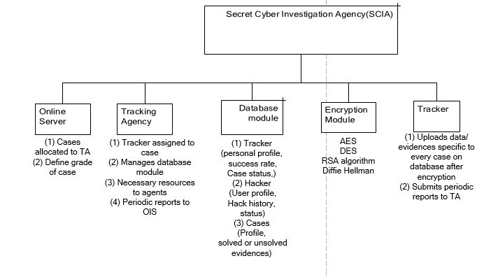

**5.3 PERT Chart : (Activity Network Graph)(Performance Evaluation review Technique)**

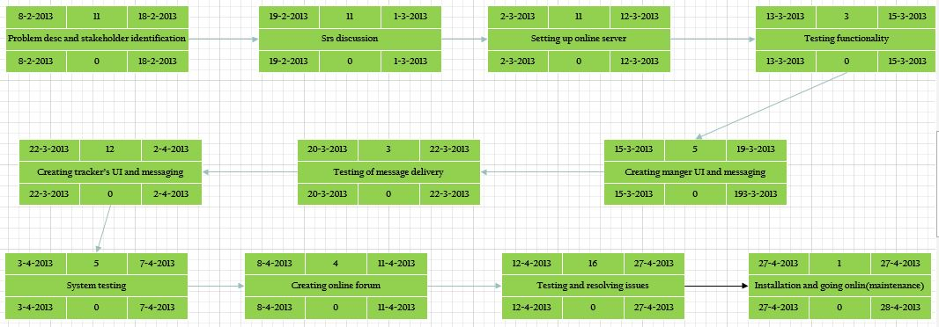

* 1. **Gantt Chart : (Bar Graph)**

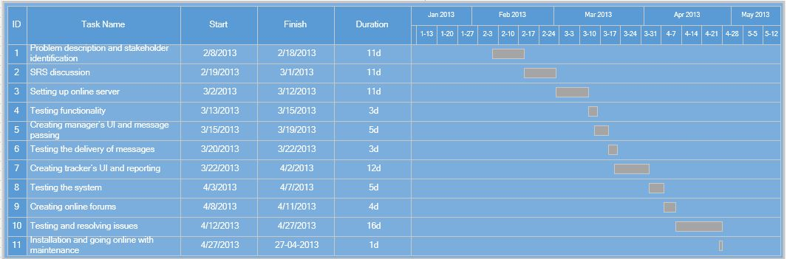

* 1. **Timeline Chart:**

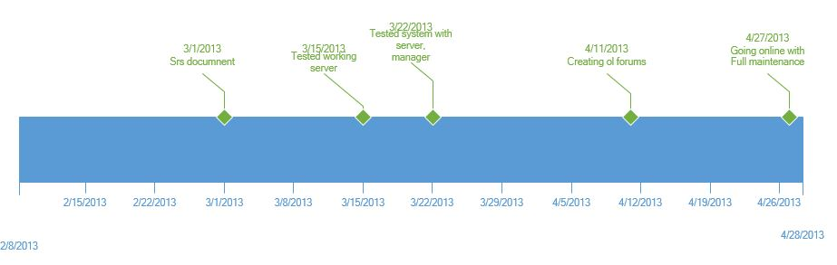

1. **PROJECT RESOURCE REQUIREMENTS:**

**6.1 HARDWARE RESOURCE REQUIREMENTS:**

* Minimum RAM 512 MB
* Minimum disk Space : 500 GB
* Processor Intel Core 2 Duo 2.4 GHz Minimum
* Server for Trackers.

**6.2 SOFTWARE RESOURCE REQUIREMENTS:**

* Windows XP(service pack).
* Oracle 11G.
* .Net Framework
* Rational Rose Enterprise Edition.
* Microsoft Visio 2013.
* Creately.com(WBS).
* Agro UML.
* Browser(internet explorer 6.0 or above).

**7. RISK MANAGEMENT:**

7.1 **Risk Management Strategy:**

Priority in which the data is hacked is based on the Weight of the customers complaint,in such a way that (Credit card detail retrieval> facebook account getting hacked). The precedence is already predefined and we have to have the maximum no. of necessary resources and not resources that are used for luxury for the trackers,to avoid any kinds of business risk.

7.2 **Initial Risk List:**

|  |  |  |  |  |
| --- | --- | --- | --- | --- |
| **Risk Type** | **Risk Probability(H,M,L)** | **Risk Name(brief Description)** | **Mitigation Strategy** | **Effect on Project** |
| Product | H | System Failure or the Server going low. Then the phisher can pounce on the sites. | Proper Backup and Restore | Severe |
| Project | H | Hierarchial Fault(Since 1 person has a control over the other,if someone gets lazy all the sub-trackers are affected). | Employment based on trust,qualification than just recommendation. | Adverse |
| Business | L | Insufficient number of resources. | Provide adequate number. | Moderate |
| Product | Very Low | Phisher tries to hack through the online server. | Doesn’t happen usually.Only due to negligence | Catastrophic |
| Project | M | Database gets corrupted. | If there is a problems like redundant data storage. | Insignificant |
| Project | L | Tracker can go rogue. | We will make sure it doesn’t happen. | Very catastrophic. |
| Business | M | Insufficient number of trackers. | Other Agency may have more trackers. | Loss. |

**8.)User Requirements:**

***8.1 Functionalities***:

8.1.1 Online Server-

The online server is basically a team which comprises of experts who take the responsibility to handle cyber-crime cases.

User End of OlS:

8.1.1.1 Input- Username and password

8.1.1.2 Output- User Authentication and appropriate messages

8.1.1.3 Description- Proper login facilities to ensure user verification. Appropriate privileges to appropriate users.

8.1.1.4 Action- The application accepts username and password entered by user. Checks for validation of the user and alerts user about acceptance or denial.

8.1.1.5 Precondition – Username and password must be provided to use the server functions.

8.1.1.6 Post condition- Alert message about the acceptance or denial of username-password after confirmation.

8.1.2 Tracking Agency- The agency is a group of highly skilled personnel who have been recruited by the online server who assign cases to trackers and maintain reports to ensure a cyber-crime free environment.

8.1.2.1 Input- Employees need to fill in details like:

User_id

User_name

User_category

* + - 1. Output- Auto generated messages, alerts for users. Case progress and status reports of each case
      2. Description- System retrieves information from every tracker; all information regarding every case is accessible to the agency.
      3. Action- The agency assigns trackers for every case based on the case grade. The trackers are recruited to sniff out hackers who have breached security of shopping forums and firewalls of home users.

8.1.2.5 Precondition- Tracking agency provides case details and receives updates from trackers. The agency maintains the database and assists trackers with required information to handle cases.

8.1.2.6 Post condition- Alert messages and status reports from trackers.

8.1.3Tracker-Trackers are skilled experts at sniffing down hackers and handle cases assigned to them discreetly.

8.1.3.1 Input- Trackers need to fill in details like:

tracker_id

tracker_name

tracker_category

tracker_grade

8.1.3.2 Output- Auto generated messages, alerts for users. Case progress and status reports of each case. All received information from the agency which can help the tracker to track down hackers.

8.1.3.3 Description- The information gathered by the tracker is uploaded after encryption. Navigation and resource assistance from the agency.

8.1.3.4 Action- The trackers are assigned cases based on the agent grade. The trackers are recruited to sniff out hackers who have breached security of shopping forums and firewalls of home users.

8.1.3.5 Precondition- Trackers are given specific details for every case and all sorts of assistance to prevent cybercrime.

8.1.3.6 Post condition- Alert messages from the tracking agency and cases from the agency for their next target.

* 1. ***User Characteristics:***

-> The user should be familiar with the Online related terminology like Admin, web-site and different hierarchies of business processing.

-> The user should be familiar with the Internet and browser operations.

-> The user must know all about the behavioural client-server architecture system modelling and also about the different types of agency details and basic security systems.

# **9. External Interface Requirements:**

**9.1 User Interfaces**

* The system will provide GUI for the users.
* The users will be able to access the system using their web browsers
  1. **Hardware Interfaces**
* The system will have an interface with the finger print scanner.
* The system will have an interface with the digital camera to capture images of the phishers and will be used for face recognition
  1. **Software Interfaces**
* The system will have an interface with the Website for authentication of details and security check.
  1. **Communications Interfaces**
* The system will use HTTPS protocol for secure transfer of information between the client and the web server once the firewall is updated and the trackers deploy encryption standards.

**10. SYSTEM REQUIREMENTS :**

***10.1 Requirement Gathering:***

All the requirement gathering that has been done till now can be shown by an informal dependency check measure called as the traceability policy for end users.

They consist of 3 types :

->Source Traceability.

->Requirements traceability.

->Traceability of Design.

This can be comprehensively represented altogether by a mathematical matrix representation called as the Traceability matrix.

***10.1.1Traceability matrix:***(source, requirements affected and modules developed)

|  |  |  |  |  |  |
| --- | --- | --- | --- | --- | --- |
| Participating Entities | Online Server | Tracking Agency | Tracker | Hacker | User |
| Online Server |  | R | R |  |  |
| Tracking Agency | R |  | S | D | D |
| Tracker |  | R |  | D | R |
| Hacker |  |  |  |  | D |
| User | R |  | S |  |  |

***10.2 Functional Requirements :***

The following are the functional requirements for the system:-

10.2.1 The **online server** receives cases of breach of security or collapse of the firewall of any intelligent system in the case of an online shopping forum or if a home user has been attacked and vital personal information has been stolen.

It is the task of the online server to define the grade of each individual case in a particular order of precedence. The priority of each case is of utmost importance as based on this merit the cases are assigned to the tracking agency.

The online server allocates cases to the tracking agency. It has the privilege to send the following details to the agency:

* + 1. Name of cyber-victim
    2. Type of case
    3. Case suspect
    4. Expected time duration
    5. Grade of case
    6. Other details (specific to a particular case)

Online server receives periodic reports compromising of the information below from the agency.

1. Status of hack and investigation
2. Suspect details
3. Crime details
4. Evidences in support of case

10.2.2 **Tracking agency** consisting of the tracking supervisors who keep details of all trackers it employs with the following databases:

Tracker Profile

* + - * Personal Details
      * Tracking History
      * Success Rate
      * Type of Tracker (specifies domain of expertise)
      * Grade of Tracker (depending on success rate and experience)
      * Current Status (occupied/unoccupied)

Suspect Profile

* + - * Personal Details
      * Cyber-crime Record

Case Profile

* + - * Solved or unsolved
      * Case details
      * Case grade (priority level)

The tracking agency appoints appropriate trackers who are technically skilled and capable of acquiring potent information regarding the cyber-crime and have the abilities required catching the suspect and preventing further online frauds or breach of security.

These trackers are assigned to tasks based on their merit and success rate. The grade of a case is mapped to the ability of the tracker.

Tracking agency receives formal periodic updates from all trackers working on various cases, including the status of the investigation and suspect details.

* + 1. **Trackers**

a) Receives detailed of case from the Tracking agency.

b) Can be tracked down by TA using navigation and their specific access codes which indicate their location.

c) Should have the privilege to modify case details in database regarding:

* + 1. Suspects
    2. Evidences

All information/data is encrypted. The most important feature of this application is that secure transfer of information is quintessential. This requires proper algorithms to be used to encrypt data.

Algorithms like:

* RSA algorithm.

*Diffie Hellman algorithm.

*AES.

*DES.

*Image steganography.

* 1. ***Non-Functional Requirements* :**

This section describes in detail all the non-functional requirements

## Usability:

1. The system shall allow the users to access the system from the Internet using HTML or it’s derivative technologies like XML/CSS. The system uses a web browser as an interface.
2. Online help will be available for the system
3. The end users will be able to able to adapt to the system with a minimum training of 40 hours.
4. Key board short cuts will be available for all functions of the system

## Security:

* + 1. Login requirements -
       - Trackers will be provided access to the system after they are registered by their recruitment officers.
       - Trackers will be logging into the system using their ID and password designated to them.
       - New passwords will be designated to trackers on a weekly basis.
    2. Inactivity timeouts -
       - System should timeout when there is no activity for five minutes.

## 10.3.3 Performance:

1. Response time should be very fast <5 seconds for 95% of requests.
2. Fast transfer of data (>50 Mbps)

## 10.3.4 Capacity:

1. The application shall be able to successfully handle 500 requests per hour
2. Hard disk space – 450 GB – Content
3. GB – Transaction Logs

## iii) Not more than 2 cases can be assigned to one tracker at a time.

## 10.3.5 Recovery:

1. The system will be recovered within one hours from the down time
2. A full back up of data is done with every updating of database in case of failure.
3. The backup tapes when removed from the server are stored securely in a locked fire-proof safe.

## 10.3.6 Availability:

1. The system will be available on all days 24*7. All functionalities will be operational on all days.

## 10.3.7 Reliability:

i) Mean Time between Failures – The mean time between failures for the system will be very high (> 5000 hours)

## 10.3.8 Maintainability:

1. Mean Time to Recovery – The Mean Time to Recovery (MTTR) should be very less. (<5 hours)

## 10.3.9 Portability:

1. The system will run on windows 95/98/2000/NT/XP/Vista/Windows7/Windows8

## 10.3.10 Privacy :

1. The details of all trackers employed are strictly confidential and can be accessed by only qualified officials from OlS and TA.

The database of criminals and cases can be accessed only by officials possessing particular access codes for specific records.

* 1. **Domain Requirements:**

Domain requirements reflect the environment in which the system operates so.

Basically, this project functions on the government domain where it works like a secret service agency that catches crooks who perform fraud online and an agency that aims to do nothing but justice to public.

* + 1. **Exactness:**

**->** The project is made in such a way that it assists only users in the online shopping forums, people having personal bank accounts and social networking sites.

**10.4.2 Implicitness :  
 ->** The supervisors in the TA must make sure that the recruits are skilled enough to handle cases given to them by the users.

**10.4.3 Understandability :**

**->**Requirements are expressed in the language of the application domain.

**->** This is often not understood by the software engineers developing the project.

**->**This is very clearly understood by any IPS agent or secret government service agent who does work for tracking criminals manually.

**11. Object Oriented Analysis and design:**

The project’s functional requirements can be perfectly represented in an object oriented view using diagrams.It is easy to understand from diagrams than reading all this documentation for a lay man.So,we try to implement all the details using different graphs and case diagrams which help us complete list our project and divide it into certain different modules for further development.

**11.1Use Case diagrams:**

**11.1.1.1 For The whole scenario:**

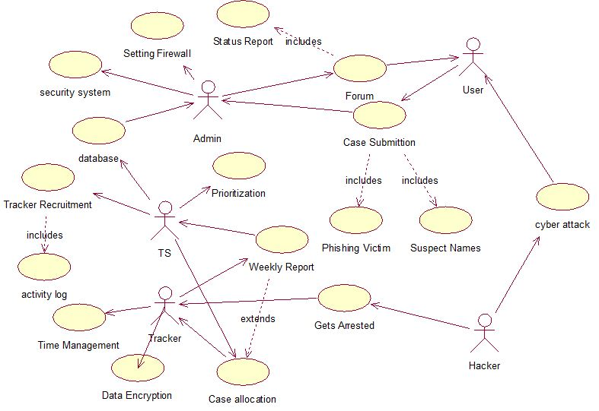

***11.1.1.2 ACTIVITIES OF THE USE CASE DIAGRAM:***

|  |  |
| --- | --- |
| Database | It is the data of the trackers, phishers,cases and the customers stored inside as a data dictionary. |
| Security System | The security maintained by the admin so that people do not hack into their own system, let alone the other social networking sites. |
| Setting Firewall | With permissions from different websites, the ADMIN or the Online Server can keep the firewall settings of them updated so as they have the current versions and the best possible protection from potential hackers. |
| Forum(includes Status Report) | All details like case status(caught or still in progress),case priority,predicted time and trackers involved are all present in a websites blog which can be constantly checked by users called forum. |
| Case Submission | The process in which the customer or the victim lodges a case on an expected suspect or a potential threat who had stolen details from him(hacked his account) with or without his knowledge. |
| Cyber Attack | An attempt made by the phisher to attack and hack into the person’s data account(SN site or credit card details) is called cyber attack |
| Prioritization | The method of assigning a priority to the case based on the level of the data stolen or the impact of the hit is called prioritization.It is done by the TS. |
| Tracker Recruitment(includes activity log) | The TS recruits the specialized trackers for each domain based on their specialization or expertise in their required field so that they have a high efficiency in catching hackers. |
| Case Allocation | The flow where the TS assigns the case to the best and unburdened tracker to take up a certain case is called as case allocation. |
| Weekly Report | A report is submitted to the the TA by the trackers to keep pace in the case and to let the customers know the progress,the TS checks the status and reallocates the case to the tracker. |
| Data Encryption | The trackers encrypt the customer’s site page and apply algorithms to sniff out the third party user and report them red handedly. |
| Time Management | It is the job of the tracker to complete the higher priority job in the least amount of time, if he fails to do so he gets a bad mark in his activity log and fails to get good cases and loses tracker reputation. |

**11.1.2 For the login and Admin-User Relationship phase:**

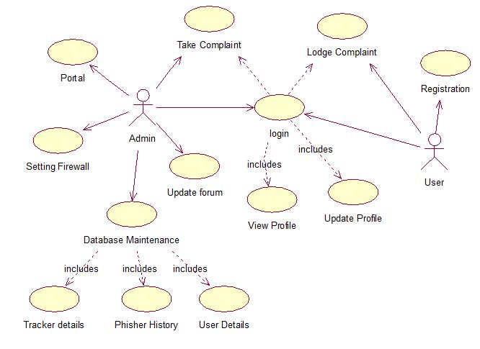 **11.2 Data dictionary(ER module)**

Since this project is one to be implemented and a virtual approach to how things are done, we don’t have enough details to make an ER diagram of its entities, although a Data Dictionary can be perfectly drawn based the characteristics the modules have.

|  |  |  |  |
| --- | --- | --- | --- |
| **Sno./Entities** | **Tracker details** | **Case/Hacker Details** | **Customer Details** |
| **1.** | Tracker_name | Cyber crime record | Customer_name |
| **2.** | Tracker_id | Case grade | Customer_no. |
| **3.** | Success_rate | Case_id | Customer_email |
| **4.** | Tracker_category | Case_status | Customer_id |
| **5.** | grade | Suspect_namee | Customer_status |
| **6.** | Tracker_status | Track_record | --------------- |

**11.3 System Design:**

**11.3.1 Sequence Diagrams:**

**11.3.1.1 Registration Sequence:**

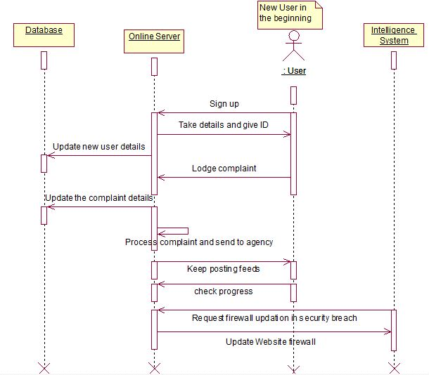

**11.3.1.2 Work Allocation Sequence :**

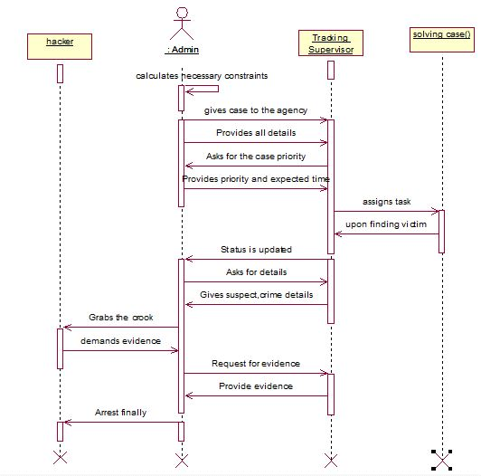

**11.3.1.3 Case Solution :**

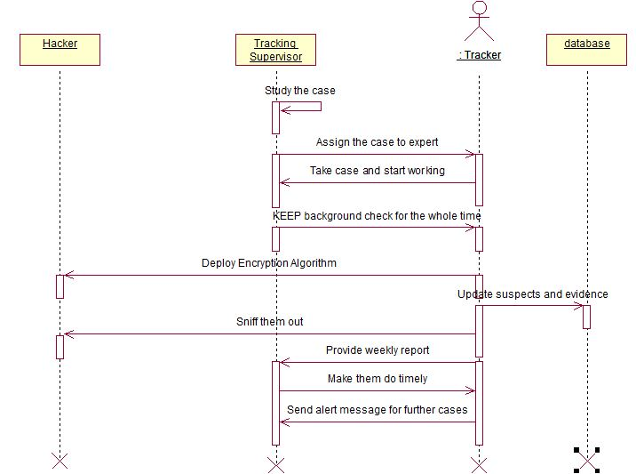

**11.3.2 Collaboration Diagrams:**

**11.3.2.1 Registration :**

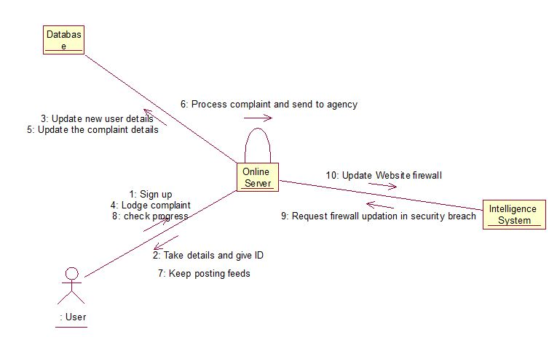**11.3.2.2 Work allocation**

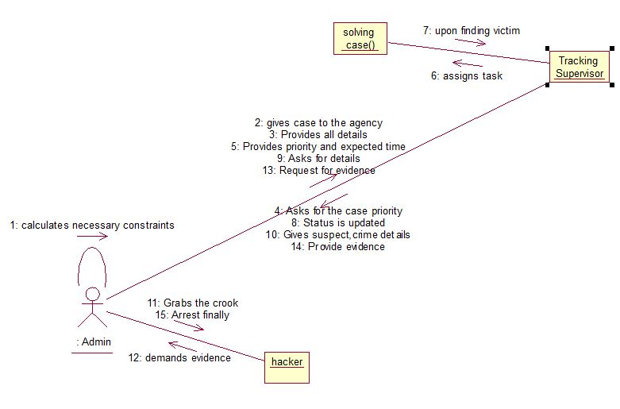

**11.3.2.3 Case solution :**

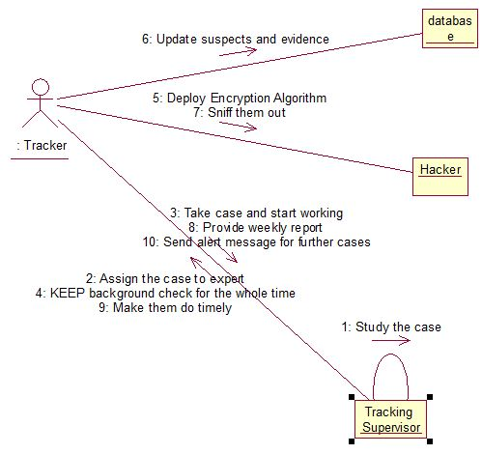

**12. Architectural Model identification and Explanation:**

**12.1System Structuring:**

This project is a typical Web based application module,and thus needs to be implemented by a **client-server** architecture.

**12.1.1Architecture diagram**

Security System

Data Dictionary

Access to online Server

CYBER INVESTIGATION AGENCY

Encryption Module

Tracker’s and Hacker’s Database

Agency Work Space

**12.2Control Models:**

Our project is driven by an online hierarchy that controls the TS which eventually controls the trackers.So,we can try to implement by using a top-down **CALL-RETURN** model.

Here,we have to supply the input and we get the necessary output as specified in the user requirements(functionalities) in chapter 8.1 of the project.

Otherwise,we try to implement all the modules in Behavioral approach that is suitable for use as there is a small database and less collection with more implementation.It mainly consists of the data flow diagram that shows the complete flow of the project.

**12.2.1 Data Flow diagram:**

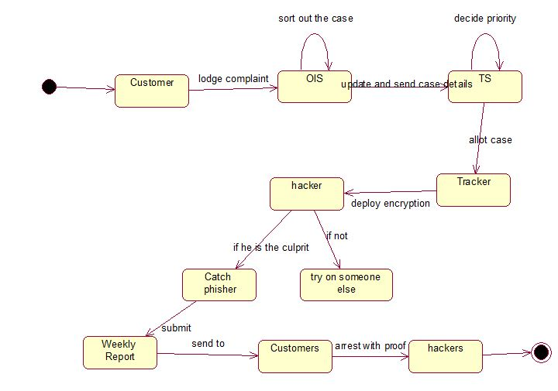

**12.3 Modular decomposition.**

Since a subsystem cannot work on its own,we have to make it into a complete system and divide it into separate modules based on functionalities.There are 2 approaches that can be used.

->Bottom-Up :

It is not generally preferred,all the modules are divided into typical diagrams and a study is made,but very easy for requirement gathering.

->Top-Down Processing:

It is generally preferred as in done by software engineers because the more we get to divide it from the top,the more clear it gets for us the more easy to perform operations.

*We follow neither Top-Down nor bottom-up approach because our SRS phase consists of half of each from an opposite direction and we also let it flow in such a way and make it easy for us.